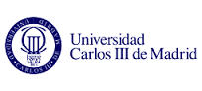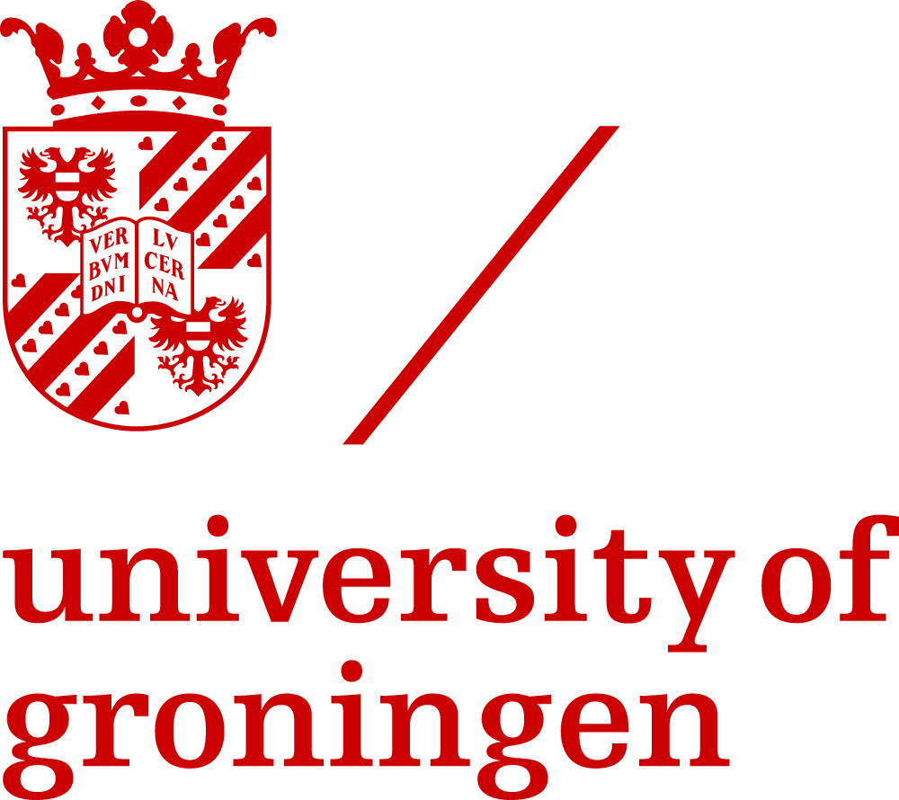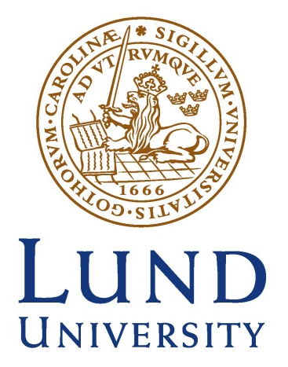

MEDEG
Master in
Economic Development and Growth

CV Form
Personal information
Name and Surname
Address (House number, street name, postcode, city, country)
Telephone
Fax
E-mail
Nationality
Date of birth (dd,mm,yyyy)

Education and training |  | Add separate entries for each degree and training course you have completed, starting with the most recent, by copying and pasting the template enclosed below as many times as necessary.

Dates (from MM/YYYY to MM/YYYY)
Name and type of organisation
Main courses
Title of degree awarded
Statutory duration
Total Credits according to national system
Equivalence in ECTS credits

RESEARCH AND PROFESSIONAL EXPERIENCES |  | Add separate entries for each research and/or professional experience, starting with the most recent, by copying and pasting the template below as many times as necessary

Dates (from MM/YYYY to MM/YYYY)
Name and address of employer
Employer’s field of activity
Position held
Main activities and responsibilities

Personal skills and competences |  | Acquired in the course of life and career but not necessarily covered by formal certificates and diplomas. Please describe which experiences and circumstances allowed you to develop such skills.

Mother-tongue
Other languages

Social skills and competences
Living and working with other people in multicultural environments, in positions where communication is important and teamwork is essential, etc.
Organisational skills and competences
For example coordination and administration of staff, projects, budgets; ability to meet deadlines, etc.
Technical skills and competences
With computers, specific kinds of equipment, machinery, etc. Please describe these competences and indicate how they were acquired

Additional information
Personal Interests
any other information that may be relevant for the selection process

